## modeling the load flexibility potentials for ice energy storage

Karl Heine1, Paulo Cesar Tabares-Velasco1, Ryan Meyer2, and Michael Deru2

1Colorado School of Mines, Golden, CO

2National Renewable Energy Laboratory, Golden, CO

# ABSTRACT

With the increasing interest in grid-interactive efficient buildings, energy storage technologies are being re-evaluated for their role in the future grid. Ice thermal energy storage (ITS) has a large potential to provide load flexibility to a grid dominated by variable generation assets, but it requires careful design, analysis, and control to be effective. Evaluation is possible using building energy simulations, but is not often done because of the complexity and added effort required to include ice storage in building simulation models. The objectives of this study are two-fold: (1) automate the addition of ice energy storage to building models through OpenStudio measure scripting and (2) evaluate the load flexibility potential of example ITS design and control strategies. This paper presents a new OpenStudio measure that provides the ability to easily and accurately model a variety of potential design options and common control schemes. After applying this measure, we then bound the ability of the building to increase or decrease its predicted future electric load over 30-minute to 6-hour windows using chiller and ice storage performance constraints at each simulation timestep. Finally, we evaluate the ITS performance against in-simulation demand response events.

# introduction

Considering the increase in uncertainty and electricity generation variability on the grid due to the growth of renewable assets and distributed energy resources (DERs), buildings are an emerging asset for dynamic demand response and grid services. One of the largest electrical end-uses within buildings is space conditioning, accounting for 9% of the total U.S. electricity production, and up to 50% of a building’s total electricity demand during summer (EIA 2012). This vast amount of energy use is theoretically controllable through the use of thermal energy storage. Ice has traditionally been used to shift on-peak daytime cooling loads to off-peak nighttime hours, capable of providing significant energy cost savings (Henze, Krarti et al. 2003). And if properly sized and controlled, it can also provide a reduction in total facility energy use (MacCracken 2003). In a grid dominated by renewables however, this strategy may be insufficient – the dynamic flexibility of a given system’s design and control sequence should also be assessed. Some recent work on the value ice thermal storage (ITS) for flexibility and promoting penetration of renewables has begun exploring this topic (Van Asselt, Reindl et al. 2017, Tang, Wang et al. 2019).

The U.S. Department of Energy Buildings Technology Office (BTO) characterizes building demand flexibility as: (1) energy efficiency, (2) load shifting, (3) load shedding, and (4) load modulation (Neukomm, Nubbe et al. 2019). ITS can readily address the first three characterizations; however, it is not well suited for load modulation due to the short timesteps required (seconds and sub-seconds).

The traditional design approach to ice systems is based on load shifting evaluated over a design-day. Chillers may then be downsized, thereby decreasing capital cost and improving device efficiency during part-load operation (Glazer 2019). These factors then impact the building’s overall efficiency, with potential to reduce energy use intensity (EUI).

Ice storage also provides a load shedding ability within a building. The ice available within the storage tank at each point in time can be converted into a temporary reduction in building electrical demand (load shed). Conversely, a partially discharged ice tank and/or a chiller operating with a demand limiter provides an opportunity for a temporarily increase in building demand while saving the stored ice for later (load add). This may be a useful service in the event of excess renewables that might otherwise be curtailed. Thus, ice storage system designs and controls should be evaluated for their ability to provide both load shed and load add in a grid-interactive manner.

To perform load flexibility assessments, detailed whole-building energy modeling (BEM) that incorporates an accurate ice energy storage model with proper controls is required. While most BEM software can simulate ice storage systems, implementation is a time-consuming, custom endeavor (Glazer 2019). This limits parametric analysis potential and more wide-spread consideration. Furthermore, controlling the ice storage models may require scripting within the HVAC iteration loops in order to achieve performance similar to real-world applications. These challenges have limited the analysis of ITS within BEM to date.

Thus, the objective of this paper is to present a method to automate the implementation of ITS within BEM and allow users to quickly define and evaluate a wide variety of possible control schemes, even permitting the testing of a system during a simulated demand response event. This allows rapid parametric analysis of possible ice storage system designs and high-level control strategies. We demonstrate the measure on a single building model, exploring several configuration and control options. We then examine the impact of each design option on building energy efficiency, electrical load shifting, and ability to provide temporary load shedding or addition in response to a grid event.

METHODOLOGY

Measure Description

EnergyPlus is the BEM engine used for this project, including the ThermalStorage:Ice:Detailed object, accessed through the OpenStudio Software Development Kit. The measure can be implemented directly within the graphical user interface, from the command line, or as part of a scripted workflow. The measure may be applied to any OpenStudio model that includes a chilled water loop.

The configuration options available in the measure include the ice tank position relative to chiller, the ice tank capacity in ton-hours, and a chiller capacity multiplier.

The high-level control strategies available within the measure are those defined by the ASHRAE Design Guide for Cool Thermal Energy Storage:

* Full Storage, where the ITS meets the entire cooling load during discharge; and,
* Partial Storage, where cooling loads are met by simultaneous operation of both the chiller and ITS.

Within partial storage, there are many additional control considerations, such as load-leveling, demand-limiting, and chiller or storage-priorities. All of these may be implemented through user inputs within the measure, thus allowing comparative analysis. Due to the nature of EnergyPlus, demand limits [kWe] on the chiller are implemented as capacity limits [kWth] within simulation. Figure 1 shows a selection of the measure’s user inputs related to ITS configuration and controls.

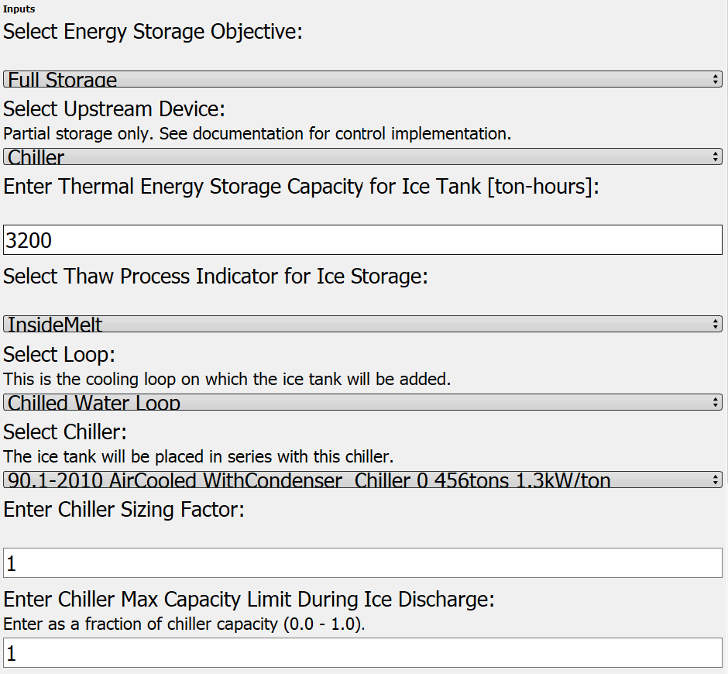

Figure 1 Select user inputs for ITS measure

All controls, with the exception of the chiller capacity limiter, are provided through component operating schedules, which are created by the measure for the user. Custom schedules generated by the user may also be applied. The chiller capacity limiter is controlled by a simple Energy Management System (EMS) script inside the HVAC iteration loop.

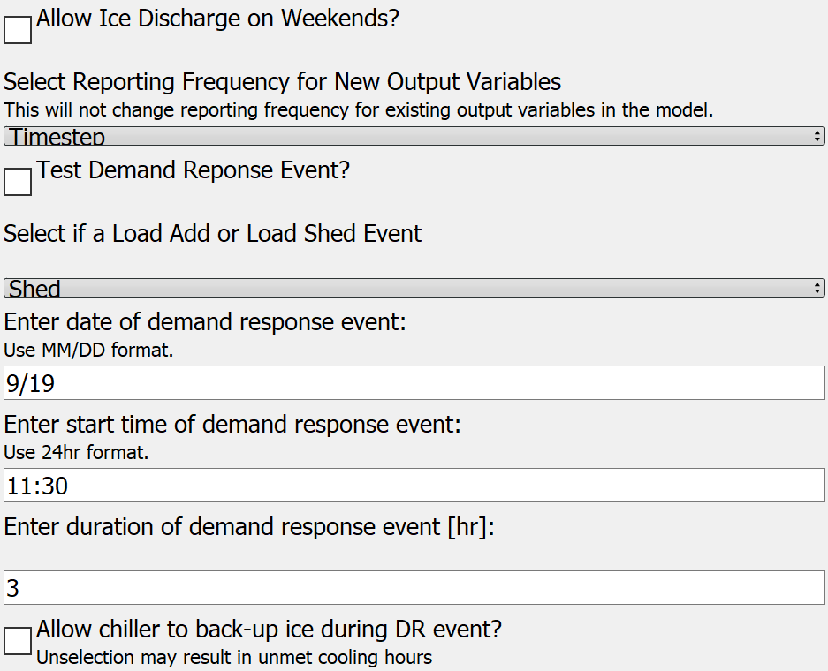

Figure 2 User inputs for demand response tester

One additional feature of the measure is an optional supervisory control EMS script that can be used to test partial-storage designs against user-defined demand response (DR) events. The DR tester overrides the routine ITS controls for a user-specified event time and duration to either maximize (load add) or minimize (load shed) energy use associated with space cooling. The in-simulation tester is valuable for exploring the rebound effects associated with using ITS for dynamic load flexibility. Figure 2 shows the user inputs for the DR tester.

## Flexibility Metrics and Methods

We evaluate the ITS models against a variety of energy metrics associated with the BTO’s characterizations of load flexibility mentioned above. Cost metrics are not discussed here as they are functions of not only design and control, but also local utility rates and programs. Cost considerations may be evaluated by applying the appropriate tariffs and demand response incentives. This measure provides a tool to help evaluate ITS within any price structure.

Load shifting is evaluated relative to a baseline system without ITS. It involves both the ice discharge and subsequent recharge periods. The peak power reduction [kWe] during discharge and the total electric energy shifted [kWh], evaluated over at least one complete charge/discharge cycle are useful. We consider the four metrics below to characterize the load shifting potential of our example ITS models:

Average Daily Shifted Load [kWh], defined as the average reduction in facility electricity use during ice discharge, relative to the baseline;

Average Fraction of Daily Load Shifted [-], defined as the average of the daily shifted loads divided by the average daily total electric load in the baseline;

Annual Total Shifted Load [MWh], which is the sum of the reductions in daily facility electric load during ice discharge, relative to the baseline; and,

Maximum Annual Peak Demand, which is the single point of maximum facility electric demand (15-minute average) over the course of the year.

Monthly values for peak demand are of interest for utility rate calculations; but for brevity, we here present only the annual peaks which, in our demonstration cases, equate to late summer peak demand.

Energy efficiency is evaluated at the building level with EUI, and at the chiller level through three metrics evaluated over the ITS operating season to capture charge and discharge performance:

* Chiller Average COP;
* Chiller Total Electricity Use; and,
* Chiller Total Runtime Hours.

Load shed and load add potentials are assessed through both post-processing of simulation results and through the in-simulation DR tester. They are quantified in terms of peak power [kWe], energy [kWh], and potential duration of flexibility [hours] at each simulation timestep. We perform the calculations for DR events ranging from 30-minutes to 6 hours.

For the load shed events, we assume that ITS controls switch their routine partial-storage control to full storage for the duration of the event, thus allowing the chiller to turn off. If the ITS state of charge (SOC) is insufficient to meet the full load (either energy or cooling rate) over the required duration, we indicate a 0 flexibility potential. We do this to identify the limits of a particular ITS control strategy for early-design consideration.

For load add events, we assume that the chiller will meet the full cooling load. Any ice that would have been discharged during the DR event is saved for later use.

We aggregate these calculations, performed at each timestep for each DR window (30-min to 6-hours), into average potential power change [kWe], average potential energy change [kWh], and the availability of the response type. This availability is defined as the percent of timesteps over which the complete shed or add responses could be successfully executed. For example, at a given timestep, a system may be able to switch to full storage and meet the future cooling loads (determine from baseline model) the next hour, but not for any longer duration. In this case, 30-minute and 1-hour responses are considered available at the given timestep, where 2+ hour responses are not. Availabilities are presented as percentages of annual timesteps and of only the occupied timesteps.

These add and shed potentials derived from post-processing provide information on the flexibility that the building may provide to the grid only during the DR window; they do not capture any rebound effects. In the case of the load shed events, negative rebound impacts may occur immediately following the DR event or several hours later during ice tank recharge. The in-simulation DR tester allows us to use BEM to capture those rebound effects. These are best explored through visual examination of the timestep energy output data.

## Simulated Building Test Cases

To demonstrate the capabilities of this measure and our load flexibility analysis, we use the DOE Prototype Secondary School, vintage 90.1-2010 for climate zone 2A, with the Houston, TX TMY3 weather file, simulated at 15-minute timesteps. We select this building model and location because (1) the building cooling is provided through a primary-secondary chilled water loop supplied by a single air-cooled chiller, (2) the facility in this location requires space cooling for the entire year, and (3) space cooling constitutes a large percentage of the total facility electric load. In order to facilitate study repeatability, no changes are applied to the model beyond our ITS measure. The peak cooling period for this model occurs during September when high occupancy is coincident with hot and humid weather conditions.

To showcase the potential of the measure five different ITS configuration and control cases are modeled and presented here. Cases with a “P” title are partial storage configurations.

Table 1 Model configurations

|  |  |  |  |
| --- | --- | --- | --- |
| Case | Chiller Capacity | ICE  capacity | UpStream Device |
| *Tons (kWth)* | *Ton-hr (GJ)* | *-* |
| Base | 578 (2,033) | N/A | N/A |
| Full | 578 (2,033) | 3,200 (40.5) | Ice |
| P1 | 405 (1,424) | 2,000 (25.3) | Ice |
| P2 | 405 (1,424) | 2,000 (25.3) | Chiller |
| P3 | 347 (1,220) | 2,000 (25.3) | Chiller |

Table 1 lists the five cases and their basic configuration options. Using percentage multipliers, the chillers in P1-P3 are downsized from the original baseline. Chiller capacities in Table 1 are the result of a 70% multiplier in models P1 and P2, and a 60% multiplier in P3. These multipliers are selected based on the ASHRAE Design Guide for Cool Thermal Storage sizing equations and recommendations in order to demonstrate the performance of systems with downsized chillers (Glazer 2019).

Table 2 Model control strategies

|  |  |  |  |
| --- | --- | --- | --- |
| case | sTRATEGY | pRIORITY | lIMITER |
| Base | N/A | N/A | N/A |
| Full | Full Storage | N/A | N/A |
| P1 | Partial Storage | Chiller | 57% |
| P2 | Partial Storage | Ice | 65% |
| P3 | Partial Storage | Ice | 68% |

Table 2 defines the high-level control strategies applied in each model. For model P1, the limiter imposed on the chiller during ice discharge is a function of a fixed temperature difference across the downstream chiller evaporator. This is applied using temperature setpoint schedules, rather than the EMS limiter script used in P2 and P3.

The cooling season for these buildings encompasses the entire year. The full storage system charges from 2100-0800 daily, and discharges from 0900-1800 on weekdays. The partial storage systems charge from 2300-0800 every day, and discharge from 0800-2100 on weekdays. The chilled water loop temperature setpoint is 44°F (6.7°C) with a design loop temperature difference of 10°F (5.6°C). The working fluid is 25% ethylene glycol.

To charge the ice tank during the overnight hours, the primary loop is isolated from the building cooling coils and the chiller cools the working fluid to 25°F (-3.9°C). This results in a reduced chiller capacity equal to approximately 65% of the nominal capacity during ice charging.

These models are selected to concisely demonstrate the variety of configuration and control options made available through the OpenStudio measure.

To demonstrate the flexibility analysis described above, we select one model for further examination. Case P2 (partial storage, chiller-upstream, storage-priority, with a 65% chiller capacity limiter imposed during ice discharge) is selected because it produces an approximately equivalent EUI to the baseline model, and has nearly identical total chiller electric energy use over the course of the year.

# Results

Comparing Example Models to Baseline

All five cases are evaluated in terms of energy efficiency and load shifting over the entire cooling season; and all five meet zone temperature requirements for full the year. The minimum annual ice tank SOC is checked to ensure thermal storage capacity is sufficient for all cases. These are shown for measure demonstration purposes; conclusions on the superiority of a configuration or control strategy should not be drawn from the data below. Such conclusions will depend on the building type, climate, and energy objectives.

Table 3 Annual facility metrics

|  |  |  |  |
| --- | --- | --- | --- |
| Case | EUI | Peak Demand | Min SOC |
| *kBtu/ft2* | *kWe* | *-* |
| Base | 49.5 | 989 | N/A |
| Full | 50.1 | 797 | 12.3% |
| P1 | 49.3 | 795 | 14.3% |
| P2 | 49.6 | 801 | 11.4% |
| P3 | 48.8 | 764 | 1.5% |

Table 3 summarizes the energy results for the analyzed cases. In terms of energy efficiency, all ITS are within +1.2% to -2.0% of the baseline EUI. However, all ITS reduce the facility peak electricity demand during the ITS operating season. The peak values shown in Table 3 are the maximum facility demand over the year; average monthly reductions range from 14-27%. All analyzed ITS have similar or lower unmet cooling hours compared to baseline. Annual minimum ice tank SOC values range from 1.5% (essentially empty) to 14.3%.

Table 4 Annual chiller metrics

|  |  |  |  |
| --- | --- | --- | --- |
| Case | Chiller Energy Use | Average COP | Chiller  Runtime |
| *MWh* | *-* | *hours* |
| Base | 963 | 2.55 | 5,945 |
| Full | 980 | 2.71 | 4,346 |
| P1 | 942 | 2.76 | 6,286 |
| P2 | 963 | 2.68 | 5,794 |
| P3 | 918 | 2.79 | 6,029 |

Table 4 lists each chiller’s annual electric energy use, average COP, and runtime. Examining the chiller performance between cases highlights the tradeoffs in energy use, runtime, and efficiency associated with ITS designs. All ITS models improved the average chiller COP, shown as an annual average, but most incur either increased runtime hours (P1 and P3) or increased energy consumption (Full). P2 produced nearly identical total chiller energy use, but had 150 fewer runtime hours over the year – when the ice-priority discharge was sufficient to temporarily provide full storage. This occurred occasionally in the winter and shoulder seasons.

It is noteworthy that case P2 has the same annual chiller electric energy use, but produces a higher EUI compared to the baseline. This is due to increased energy use associated with pumping the working fluid at lower temperatures.

Figure 3 September average daily profiles for facility electric demand

To better illustrate the variation in model performance, Figure 3 shows average weekday facility electric demand profiles for the month of September. Full storage ITS provides greater facility peak demand reduction relative to the partial storage models, but for a shorter duration (9 vs. 13 hours), with a higher storage capacity requirement (3,200 vs. 2,000 ton-hours), and without the economic benefits of downsizing the chiller. P1 and P2 both have the same size chiller, but the impact of the discharge priority and chiller limiter is observed throughout the day. Cases P2 and P3 have the same configuration and very similar controls strategies during discharge. However, the larger chiller in P2 recharges the ice tank more quickly each night and at a higher power requirement.

Table 5 summarizes the load shifting achieved by each ITS model. Load shifting occurs over up to 260 days out of the year (no weekends) and constitutes annual averages between 8.6% and 24.2% of the total facility electric load each day. P1 is significantly lower than the other ITS models due to the static chiller-priority control applied. This results in less average daily ice utilization compared to the ice-priority control, despite the lower fractional capacity limiter placed on the chiller.

Table 5 Electric load shifting relative to baseline

|  |  |  |  |
| --- | --- | --- | --- |
| Case | AvG Daily Shift | % Daily shift | Annual Total |
| *kWh* | *-* | *MWh* |
| Full | 1,990 | 24.2% | 323 |
| P1 | 735 | 8.6% | 189 |
| P2 | 1,617 | 20.3% | 308 |
| P3 | 1,573 | 19.7% | 342 |

The annual total shifted load cannot be directly converted into energy bill savings without local utility rates, but does illustrate the magnitude of the flexibility in energy consumption provided by a given ITS design. Its value is most easily visualized using a load duration curve, where a flatter profile means a more uniform energy demand by the facility over the year. Figure 4 shows the load duration curves for all five analyzed cases. All ITS are flatter than the baseline to varying degrees, illustrating the impact of control selections within the energy simulation.

Figure 4: Annual load duration curves for facility electric demand

Load Add/Shed Flexibility Through Post-Processing

Case P2 is used for further flexibility analysis through both post-processing and the in-simulation DR tester. The post-processing method bounds the energy use of the facility at each timestep by modifying the ITS controls for a maximum shed or add response, but it does not account for any rebound effects after termination of the DR event.

Table 6 summarizes the load shed potentials of P2, aggregated over the entire year. The average shed values represent the average reduction in facility peak demand that can be achieved over the duration of the DR event, relative to normal operation. The average energy shed represents the average reduction in facility energy use relative to normal ITS operation. This shed potential is available for a certain percentage of the year, when cooling loads are present and the ITS SOC is sufficient to meet them. The “AVAIL” column tabulates the percentage of timesteps in the year at which a full-storage demand response control is feasible for the entire event duration specified. These results assume no-notice demand response signals, where no preparatory changes in ITS operation are made prior to the event.

Table 6 Summary of annual load shed potentials

|  |  |  |  |
| --- | --- | --- | --- |
| DR eVent Duration | AvG Peak demand Shed | average energy shed | Avail |
| *Hours* | *kWe* | *kWh* | *-* |
| 0.5 | 128 | 63 | 57% |
| 1 | 123 | 120 | 48% |
| 2 | 115 | 208 | 33% |
| 3 | 108 | 267 | 26% |
| 4 | 100 | 321 | 22% |
| 5 | 98 | 386 | 20% |
| 6 | 103 | 466 | 18% |

Table 7 presents the same analysis, but limited only to facility occupied hours (8am-8pm on weekdays). In this example, the P2 configuration and control provides a shed flexibility potential of 127 kWe for 30-minute events over 63% of all occupied hours. However, for 6-hour DR events, only 90 kWe reduction in peak demand can be provided over 15% of occupied hours.

Table 7 Summary of load shed during occupied hours

|  |  |  |  |
| --- | --- | --- | --- |
| DR eVent Duration | AvG Peak demand Shed | averageenergy shed | Avail |
| *Hours* | *kWe* | *kWh* | *-* |
| 0.5 | 127 | 63 | 68% |
| 1 | 126 | 122 | 61% |
| 2 | 115 | 209 | 43% |
| 3 | 106 | 270 | 31% |
| 4 | 100 | 310 | 22% |
| 5 | 93 | 314 | 17% |
| 6 | 90 | 322 | 15% |

Table 8 displays the results of an analysis for load add events. The availability is restricted to hours with cooling load and the chiller operating at a restricted capacity. By eliminating the chiller restriction and stopping ice discharge, facility power demand is increased; the ice tank SOC is preserved for later use. Changes in peak demand are not displayed, as they are less pertinent during a load add event. Only average energy use increases are presented with their associated annual and occupied-hour availabilities. During occupied hours, it is nearly always possible to absorb additional energy as the chiller is operating under partial storage. During the late evening and early morning hours, cooling loads are small and are already being met by the chiller. This explains why the availabilities of the load add potentials during occupied hours are much higher than the full-year potentials.

Table 8 Summary of load add potentials

|  |  |  |  |  |
| --- | --- | --- | --- | --- |
| DR Event Duration | Annual | | Occupied | |
| AVG ADD | Avail | AVG ADD | Avail |
| *Hours* | *kWh* | *-* | *kWh* | *-* |
| 0.5 | 65 | 39% | 66 | 94% |
| 1 | 126 | 41% | 130 | 98% |
| 2 | 234 | 44% | 257 | 100% |
| 3 | 329 | 47% | 376 | 100% |
| 4 | 413 | 50% | 486 | 100% |
| 5 | 487 | 53% | 586 | 100% |
| 6 | 553 | 56% | 675 | 100% |

This post-processing assessment presents a method to characterize the load add/shed flexibility of a given ITS configuration and control strategy, for consideration in the early design stage. If regional utility programs heavily incentivize periodic load shed events, similar analysis can help system designers size ITS to ensure sufficient capacity will likely be available. If excess renewables frequently result in curtailed PV-generation, the analysis can quantify the potential service that a given ITS design might provide to help maximize renewable utilization.

Through the development of this measure, such analysis may now be readily repeated on a wide variety of potential ITS designs using the OpenStudio platform.

Load Flexibility Testing in-Simulation

As previously noted, post-processing does not capture the rebound effects of changing ITS control strategies in response to a DR event. We select two days during a peak-cooling week using case P2 to test and illustrate the broader effects of using the ice for dynamic load add/shed flexibility. A three-hour load shed event is simulated on September 19th, beginning at 11:30 a.m. A five-hour event is simulated for both load add and load shed on September 21st, beginning at noon.

Figure 5 shows the impacts of the three-hour shed event on September 19th from 11:30 to 14:30. Facility peak demand during the event is reduced by 239 kWe, from 787 kWe to 548 kWe. The total additional energy shifted out of the window is 688 kWh. There is no change to peak demand outside the DR event window. The ice is sufficient to supply full storage during the DR event. However, due to the additional depletion mid-day, the ice runs out before the end of the day, thus requiring additional chiller cooling over the last few hours of occupation. The required ITS recharge time is extended relative to the routine operation profile.

Discharge

Charge

DR Event

Figure 5 3-hr load shed event on Sept. 19. Rebound effects observed at end-of-day and during recharge.

Figure 6 through Figure 8 show the potential impacts of a longer DR event. This day is selected because it is one of the highest cooling loads throughout the year, thus the chiller and ITS are already operating near their design limits under routine operation. The five-hour load shed is selected to explore the impacts when the ice runs out prior to the end of the DR event.

Figure 6 5-hr load shed event on Sept. 21. Chiller operation is prohibited during DR event and ice is insufficient to meet full load. Rebound effects are immediate and severe; recharge time is also extended.

In Figure 6, the chiller is forced off for the entire event, regardless of the ITS performance. As the ice runs out, at approximately 16:00, an hour before the end of the DR event, facility electric energy increases despite the chiller being forced off. This is due to the variable speed pumps and fans ramping-up to try to meet zone temperature setpoints. During the event, peak demand is reduced from 771 kWe to 593 kWe. The additional energy shift totals 1,068 kWh. Immediately following the DR event, at 17:00, the chiller power spikes to provide maximum cooling as it attempts to recover. The spike exceeds the peak demand of the facility during routine operation, increasing the daily peak from 771 kWe to 807 kWe. As the ice is depleted, the building cannot return to partial storage control following the event; all loads for the remainder of the day must be met by the chiller. Recharge time is increased commensurate with the increased ice discharge.

Figure 7 repeats the DR test previously described, but allows for staged chiller operation during the DR event. As the ice approaches a low state-of-charge, the chiller is permitted to operate up to 50% capacity. Once the ice fully runs out this chiller limit is relaxed to the routine operation chiller limiter, which is 65% in model P2. This is not meant to simulate a smart controller, but rather to allow chiller operation to begin meeting cooling loads without a large, immediate power spike in the simulation. As the ice runs out early, a large increase in facility demand is observed as the chiller turns on at its limited capacity. Peak facility demand during the DR event is now only reduced by 50 kWe, from 771 kWe to 721 kWe. The total electricity use avoided during the event is 901 kWh. Rebound is immediate, but does not cause an increase in facility peak demand for the day. Recharge time is extended as expected.

Figure 7 5-hr load shed event on Sept. 21 with chiller operation permitted during the DR event. Immediate rebound is less severe, but peak kWe reduction during the event is greatly impacted.

Figure 8 shows the performance of ITS under a load add event scheduled for September 21st, beginning at noon. By maximizing chiller usage, and minimizing ice discharge, the facility can temporarily increase its power demand by an average of 106 kWe for those five hours. This value is a function of the building cooling load and chiller capacity, as a downsized chiller may not be able to meet the full load. This would require ice discharge during the add event, but at a reduced rate. Conversely, if the chiller is sufficiently large or the load relatively small, the chiller may be able to go into an ice-make operation during the add event, providing an even greater energy storage service to the grid.

Figure 8 5-hr load add event on Sept. 21. Chiller meets full cooling load during event and ice charge hours are subsequently reduced.

The results in Figure 5 to Figure 8 provide the information to bound on the building’s flexibility over a given DR event window. The potential increases or decreases in power or energy usage both during and after the DR event provide the necessary information to building operators (or smart controllers) to evaluate possible responses to potential grid signals.

Such analysis, previously a tedious, custom endeavor, is now easily performed on any building with a chilled water loop through the use of the OpenStudio measure developed in this project.

# Conclusion

This paper presents a new OpenStudio measure that easily models ITS systems for buildings with central chilled water loops. The measure allows users to explore various hardware configurations and high-level control strategies, and evaluate their performance through detailed building energy simulation. Furthermore, a built-in DR testing feature allows users to examine the potential impacts, including rebound, of using ITS for flexible demand response.

Four ITS models are generated using the measure and compared to the baseline. With no increase in unmet hours, facility EUI’s fall between +1.2% and -2.0% of baseline. Average daily shifted loads range from 7.4% to 13.3% of total facility electricity use. Total electric energy shifted by these example ITS ranged from 189 to 342 MWh over the course of the year.

One partial-storage model is selected for further flexibility evaluation. In addition to the load shifting previously quantified, this ITS provides average demand shed potentials ranging from 127 kWe for 30-minute events to 90 kWe for 6-hour events during occupied hours. With routine ITS operation, these potentials are available between 68% and 15%, respectively, of the building’s occupied hours.

Future work will increase the fidelity of chiller limiting controls within the measure and to extend the flexibility analysis to a wider range of ITS designs.

# Acknowledgment

This work was authored in part by the National Renewable Energy Laboratory, operated by Alliance for Sustainable Energy, LLC, for the U.S. Department of Energy (DOE) under Contract No. DE-AC36-08GO28308. Funding provided by U.S. Department of Energy Office of Energy Efficiency and Renewable Energy Building Technologies Office. The views expressed in the article do not necessarily represent the views of the DOE or the U.S. Government. The U.S. Government retains and the publisher, by accepting the article for publication, acknowledges that the U.S. Government retains a nonexclusive, paid-up, irrevocable, worldwide license to publish or reproduce the published form of this work, or allow others to do so, for U.S. Government purposes.

# Nomenclature

BEM – Building Energy Modeling

COP – Coefficient of Performance

DR – Demand Response

EMS – [EnergyPlus] Energy Management System

EUI – Energy Use Intensity

ITS – Ice Thermal [Energy] Storage

SOC – [Ice Tank] State of Charge

# References

EIA. (2012). "Commercial Building Energy Consumption Survey (CBECS)."

Glazer, J. (2019). ASHRAE Design Guide for Cool Thermal Storage**:** 312.

Henze, G. P., M. Krarti and M. J. Brandemuehl (2003). "Guidelines for Improved Performance of Ice Storage Systems." Energy and Buildings **35**(2): 111-127.

MacCracken, M. M. (2003). "Thermal Energy Storage Myths." ASHRAE Journal **45**(9).

Neukomm, M., V. Nubbe and R. Fares (2019). Grid-Interactive Efficient Buildings: Overview, U.S. Department of Energy Office of Energy Efficiency and Renewable Energy**:** 36.

Tang, R., S. Wang and L. Xu (2019). "An MPC-Based Optimal Control Strategy of Active Thermal Storage in Commercial Buildings during Fast Demand Response Events in Smart Grids." Energy Procedia **158**: 2506-2511.

Van Asselt, A., D. Reindl, G. Nellis and S. Klein (2017). Design and Utilization of Thermal Energy Storage to Increase the Ability of Power Systems to Support Renewable Energy Resources**:** 174.